

Faculty of Education

HBEF2103
The Importance of Classroom Management and Motivation in Teaching

NO. MATRIKULASI : 050718030766001
SEMESTER / TAHUN (YEAR) : 01 / 2025
PROGRAM : Bachelor of Teaching Primary Education
TABLE OF CONTENT

TITLE |  | PAGE
PART 1 | Written Assignment
1.0 | Introduction of The Importance of Classroom Management and Motivation in Teaching | 3-4
2.0 | Classroom Management Theory and Connection to Observed Behavior | 5-7
3.0 | Motivation Theory and High Engagement in Hands-on Activities | 8-9
4.0 | Conclusion | 9
PART 2 | Online Class Participation
5.0 | List of Picture | 11-12
6.0 | References | 13

- Introduction of The Importance of Classroom Management and Motivation in Teaching
Imagine walking into two identical classrooms with the same students, same curriculum and same teacher yet experiencing completely different worlds. In one classroom, students gazed listlessly out windows while the teacher’s world fade into background noise. In the other, these same students leaned forward with sparkling eyes, their hands were busy with experiments and their voices animated with discovery. We need to create this dramatic transformation in two fundamental pillars of effective teaching are classroom management and motivation theory. Classroom management creates the structural foundation for learning, establishing an environment where students feel safe, respected and mentally prepared to absorb new knowledge (Ahmed & Plessis, 2024). It minimizes disruptions, maximizes instructional time and transforms chaotic spaces into orderly learning communities.
Meanwhile, motivation theory explores the internal engines that drive students to engage, persist and excel (Mayangsari et al., 2025). When teachers understand what ignites genuine interest, they gain the power to design lessons that inspire not just inform. As a new high school teacher, I recorded my classroom for better understanding student dynamics. Upon reviewing the footage, I observed a striking behavioral pattern. During traditional lectures, many students appeared disengaged, some were socializing, doodling and looking distracted. Eyes wandered toward windows, whispered conversations competed with instruction and attention drifted everywhere except the lesson at hand (Kibga et al., 2021). However, during hands-on laboratory activities these same students demonstrated remarkably high levels of engagement and worked diligently on their tasks. They actively collaborated with peers, dove into experiments with visible excitement and demonstrated a level of focus that seemed impossible just minutes earlier.
This observation exposes a critical gap in instructional practice For examples: is the traditional lecture format fails to activate the same motivational and behavioral responses that experiential learning naturally produces. This analysis will explore two complementary theoretical frameworks that together offer a roadmap for transformation. The communication-based classroom management approach from Topic 9 provides the first lens for understanding this phenomenon. This approach moves beyond traditional control-oriented management to emphasize the cultivation of positive relationships through meaningful, respectful communication between teachers and students (Sieberer-Nagler, 2015). The second framework is instrinsic motivation theory from Topic 8, illuminates how internal psychological factors had personal interest, natural curiosity and the profound satisfaction of accomplishment serve as more powerful and enduring catalysts for learning than any external reward system (Mayangsari et al., 2025).

- Classroom Management Theory and Connection to Observed Behavior
The positive classroom climate approach from Topic 9 centers on building strong relationships, promoting mutual respect and fostering a sense of community among students (Jason J. Barr, 2016). This classroom management theory emphasizes that when students feel valued, supported and safe in their learning environment, they naturally exhibit more positive behavior and higher engagement levels. The foundation of this approach rests on communication-based management creating meaningful connections between teachers and students through respectful dialogue, active listening and genuine care for student well-being. Unlike traditional authoritarian management that relies on rules and consequences alone, positive classroom climate focuses on prevention through relationship-building and making students willing partners in the learning process rather than reluctant participants.
During my classroom recording review, students showed significant disengagement during lectures it can be directly explained through positive classroom climate theory. They were chatting among themselves, gazing out the windows, doodling in notebooks and appearing distracted by their surroundings. These behaviors are indicating more than simple boredom, they revealed an absence of the psychological safety and connection that positive classroom climate should be created. When the classroom environment does not feel inviting or when students lack meaningful connections to the teacher or their peers, they are significantly less likely to focus on instruction (Garcia-Peinado, 2024). The lecture format by its nature could create distance between teacher and students, making it difficult to maintain the relational warmth that engagement required. Without the foundation of a positive classroom climate where students feel seen, heard and valued even well-prepared lectures struggle to capture and maintain students attention. The disengagement I observed suggesting that students did not feel sufficiently connected to the learning community to remain mentally present during teacher-led instruction.
I would implement three specific relationship-building strategies there are morning meetings, personalized check-ins or use of humor and storytelling to improve students attention. First strategy that I would conduct morning meetings at the start of each day for 10 to 15 minutes. During this time, we would share daily announcements, celebrate individual and group achievement and also preview learning goals for the day. This ritual creates a sense of belonging and transitions students mentally into learning mode (Dooley, 2019). For example, I might begin by acknowledging students who helped classmates during the previous lesson then invite one or two students to share something positive from their week. By starting each class on positive note and making every student feel included, they become more invested in maintaining attention during subsequent lectures. The morning meeting establishes the emotional groundwork that makes students felt more receptive to instruction.
Second, I would schedule brief individual conversations such as personalized check-ins. We have would short, one-by-one conversations with students either during independent work time, before or after class or during designated office hours for at least once weekly. These check-ins would address student’s academic progress, any challenges they are facing and general well-being (Zander et al., 2015). For instance, I might ask, “How did you feel about yesterday’s lab activity?” or “Is there anything about the current topic that’s confusing?” When students know their teacher genuinely cares about them as individuals, they develop a stronger personal connection to both teacher and class. This connection would increased attention during lectures because students are more motivated to engage with someone who has shown consistent interest in their success and well-being.
Third, I would incorporate humor and storytelling into the lecture it can significantly boost student attention (Kaur, 2021). When teaching a complex concept, I would use relevant anecdote or funny analogies that connect to the material or reference current events and student interests. As an example, when explaining chemical reactions, I might compare them to cook disasters in my own kitchen, making the abstract concept more relatable and memorable. Humor lightens the classroom atmosphere, reduces anxiety about difficult content and signals to students that learning can be enjoyable. This approach make lectures feel less like formal information delivery and more like engaging conversations within a supportive community. When students smile and laugh during class, they are more likely to remain attentive and retain information.
These three strategies would be implemented consistently throughout every class session and across all learning activities. Morning meetings would occur at the beginning of each period, regardless of whether the day’s lesson involves lectures or hands-on work. Personalized check-ins would be scheduled systematically throughout the week to ensure every student receives individual attention regularly. Humor and storytelling would be woven naturally into all instructional modes, but also giving directions for collaborative learning tasks and interactive activities. To maintain the positive classroom climate, I would also establish clear, fair consequences for disruptive behavior that align with the relationship-focused approach. Rather than immediately issuing punishments, I would first offer gentle private reminders that preserve student dignity. For instance, if a student continued talking during a lecture after initial redirection, I might quietly approach them and say, “I notice you’re having trouble focusing today. Is everything okay?” This response shows concern rather than anger. Only if disruption continues, I would implement a brief consequence such as a temporary seat change or time-out. These consequences would be framed as opportunities to reset and refocus not a punitive measures and maintaining the positive relational foundation (Katrina Barker, 2022).
For collaborative learning tasks and group discussions, I would ensure clear, concise instructions and create structured opportunities where students work together, share ideas and learn from each other. The positive classroom climate established through morning meetings and personalized check-ins provide a foundation that makes students are more likely to cooperate during group discussions and peer learning activities. When students felt connected to their classmates through consistent community-building practices, they contributed willingly and share ideas more openly in any classroom setting (Garcia-Peinado, 2024). This consistency across all instructional modes creates a stable, supportive environment where students know they are valued members of a learning community whether listening to lectures or engaging in hands-on work.

3.0 Motivation Theory and High Engagement in Hands-on Activities
Topic 8 presents the theory of intrinsic vs. extrinsic motivation, which provides crucial insight into what drives student engagement. Intrinsic motivation comes from within an individual, driven by personal interests, enjoyment and a sense of accomplishment (Makaremi et al., 2024). When students are intrinsically motivated, they engaged in learning because they found it naturally interesting, challenging or rewarding. In contrast, extrinsic motivation is based on external rewards such as grades, praise, prizes or avoiding punishment (Makaremi et al., 2024). Understanding this distinction is fundamental for educators because intrinsic motivation creates significantly deeper and more sustainable engagement than external rewards alone. When students are intrinsically motivated, they persisted through challenges, demonstrated genuine curiosity, asked thoughtful questions and developed lifelong love of learning rather than merely completing tasks for rewards (Mayangsari et al., 2025). Therefore, effective teaching requires designing experiences that tap into student natural curiosity and desire for competence.
During my observation of hands-on activities, I remarkably noticed high engagement among students that is a stark contrast to the lecture behaviour. Hands-on activities naturally tap into several key aspects of intrinsic motivation. First, they allowed students to explore topics in practical, and interactive ways rather than passively receiving information (Thiri et al., 2024). When students manipulated materials, built things or conducted experiments, they became interested in the process itself and inherently satisfying. Second, laboratory work provides immediate feedback and visible results. For example, when students built a simple electrical circuit and saw the bulb light up, the excitement of making something work and understanding how it functions serves as a powerful intrinsic motivator. The sense of discovery, “I made this happen!” provides internal satisfaction that no grade can replicate. However, this observation also raises an important challenge to maintain or even increase this level of motivation across different learning contexts. While hands-on activities, they naturally engage intrinsic motivation, student-centered activities risk becoming routine or losing their motivational power over time if not intentionally designed. Simply providing hands-on experiences is not enough so teachers must deliberately structure these activities to continuously stimulate, provide appropriate challenges and allow for student choice and autonomy.
Proposes to maintain or increase motivation during student-centered activities, I would employ three evidences-based techniques are project-based learning with choice, self-assessment and goal setting or positive feedback and reflection. Instead of assigning identical tasks to all students, I would allow students to choose their mode of expression for demonstrating learning. Some might create traditional research papers while others might develop presentations, design museum-style exhibits, write historical fiction short stories or even produce documentary-style videos based on their research. This freedom taps directly into intrinsic motivation because students engage with topics they genuinely care about and express themselves in ways that suit their interests, strengths and creativity (Shin, 2018). When students have ownership over both what they learn and how they demonstrate that learning their motivation shifts from “I have to do this assignment” to “I want to explore this topic.” The element of choice transforms work from obligation to opportunity of sustaining motivation throughout longer more complex projects.
At the beginning of each activity, I would guide students through a process of setting their own personal learning goals and developing criteria for self-assessment. In an art class, a student might set a goal to master a new shading technique or experiment with a new medium they have never tried before. In mathematics, a student might aim to explain their problem-solving process more clearly or attempt more challenging problems than usual. After the activity, students would assess their own progress “Did I achieve my goal? What evidence do I have? What would I do differently next time?” providing regular opportunities for self-assessment helps students take ownership of their learning journey (Mcmillan & Hearn, 2008). When they see tangible progress toward self-set goals and goals they chose, it provides deep intrinsic satisfaction and accomplishment. This process teaches students to become self-directed learners who monitor their own growth, derive satisfaction from improvement and set increasingly ambitious challenges for themselves.
During student-centered activities, I would comment on effort, creativity and problem-solving skills during the process. A case in point, if a student in a math problem-solving activity developed an innovative approach to a difficult question, I would say, “I really like how you thought outside the box on this one. Your approach shows great creativity and deep understanding of the underlying concepts. Can you explain you thinking to the class?” This type of feedback reinforces the intrinsic value of the learning process itself the thinking, creating and problem-solving rather than just the final answer or grade.
Additionally, at the end of each activity we had a group reflection session where students can share what they learned, what they enjoyed and what they would do differently next time. This positive feedback and reflection help reinforcing the positive aspects of the activity and encouraging students to stay motivated in the future student-centered tasks (Fong & Schallert, 2023). This structured reflection helps students recognize and articulate their own learning growth, these making the internal rewards of learning more visible and conscious.
At the conclusion of each activity or at regular intervals during longer projects, structured reflection time would be built into the schedule. These reflection sessions might take various forms of whole class discussions where students share insights and discoveries, small group debriefs where peers provide feedback to each other, individual journal entries where students document their learning journey or even brief exit tickets where students write one thing they learned and one question they still have. They understand that the process of becoming more capable, creative and knowledgeable.

4.0 Conclusion
This analysis has explored how positive classroom climate theory and intrinsic motivation theory explain and address the engagement challenges observed in my high school classroom. The positive classroom climate approach from Topic 9 emphasizes that relationship-building, respectful communication and community-fostering create the foundation for student engagement through strategies like morning meetings, personalized check-ins and use of humor (Sieberer-Nagler, 2015). Meanwhile, intrinsic motivation theory from Topic 8 reveals that internal factors such as personal interest, curiosity and satisfaction of accomplishment serve as more powerful catalysts for learning than external rewards (Makaremi et al., 2024). Through techniques like project-based learning with choice, self-assessment and goal setting and process-focused feedback, teacher can maintain and increase the natural engagement that hands-on activities stimulate all learning contexts.
Understanding student behavior through appropriate theoretical frameworks is essential for effective teaching. When educators recognize that disengagement during lectures often stems from absent relational connections rather than student deficiencies, they can respond with relationship-building strategies instead of punitive measures. When teachers understand that high engagement in hands-on activities reflects intrinsic motivation’s power, they can deliberately design all learning experiences to tap into this internal drive (Kumar Pal, 2024). Theory empowers practice with theoretical frameworks, educators can diagnose underlying causes, they can predict student responses and select evidence-based strategies matched to specific challenges. The classroom observation that began this analysis transformed from a frustrating problem into a solvable puzzle.
Through this exploration, I have gained deeper appreciation for the complex relationship between student behavior, motivation theories and teaching strategies. I have learned that to truly engage students and create positive learning environments, I must be well-versed in multiple theoretical frameworks and able to apply them flexibly in practical situations. Moving forward, I am committed to continuously observing and understanding my student’s behavior rather than simply reacting to it regularly, I am asking myself what theories help that explaining what I observe and what evidence-based strategies address underlying causes.

5.0 List of Picture
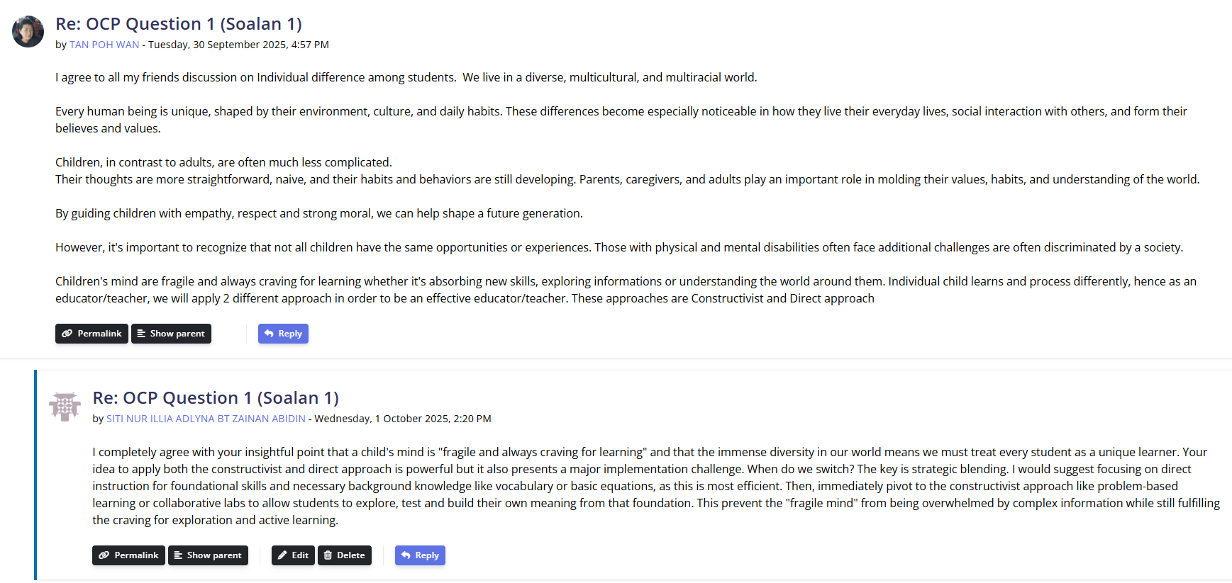
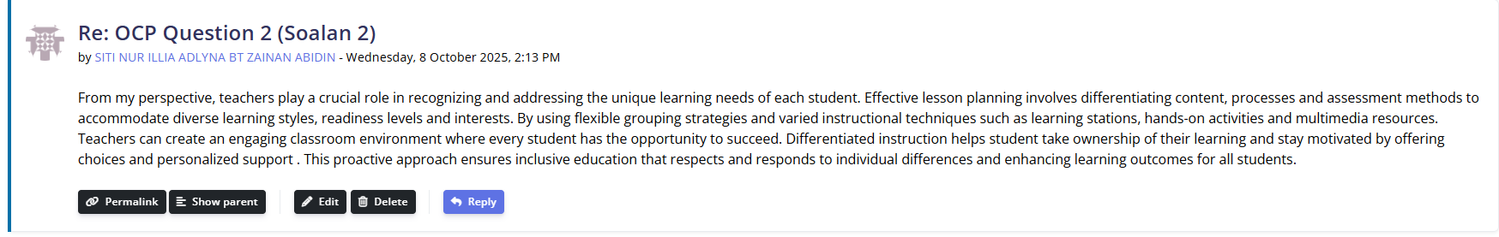

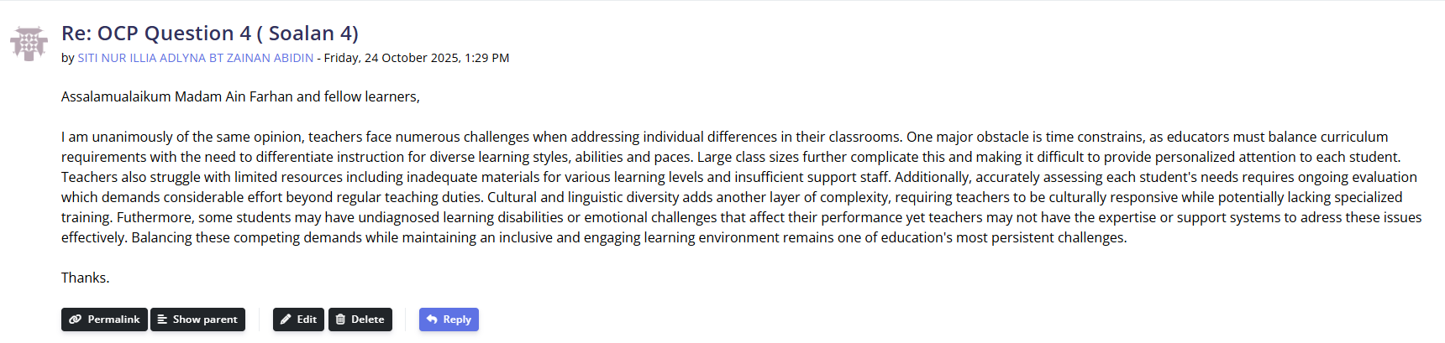
6.0 References
Ahmed, * N, & Plessis, P. D. (2024). The Role of Classroom Management in Enhancing Learners’ Academic Performance: Teachers’ Experiences. Studies in Learning and Teaching, 5(1), 202–218. https://doi.org/10.46627/silet
Fong, C. J., & Schallert, D. L. (2023). “Feedback to the future”: Advancing motivational and emotional perspectives in feedback research. Educational Psychologist, 58(3), 146–161. https://doi.org/10.1080/00461520.2022.2134135
Garcia-Peinado, R. (2024). The impact of classroom climate on emotional development in childhood. Environment and Social Psychology, 9(1). https://doi.org/10.54517/esp.v9i1.1868
Jason J. Barr. (2016). ED573643.
Katrina Barker, S. P. P. W. (2022). 9781003186236_previewpdf.
Kibga, E. S., Sentongo, J., & Gakuba, E. (2021). Effectiveness of Hands-On Activities to Develop Chemistry Learners’ Curiosity in Community Secondary Schools in Tanzania. Journal of Turkish Science Education, 18(4), 605–621. https://doi.org/10.36681/tused.2021.93
Kumar Pal, R. (2024). A review Article on Various Theories of Motivation in the Teaching Sector. https://doi.org/10.5281/ZENODO.14926187
Makaremi, N., Yildirim, S., Morgan, G. T., Touchie, M. F., Jakubiec, J. A., & Robinson, J. B. (2024). Impact of classroom environment on student wellbeing in higher education: Review and future directions. In Building and Environment (Vol. 265). Elsevier Ltd. https://doi.org/10.1016/j.buildenv.2024.111958
Mayangsari, D., Nawangsari, N. A. F., Yoenanto, N. H., & Suminar, D. R. (2025). Unraveling Intrinsic Motivation: The Key to Empowering Teacher Professional Growth. Journal Evaluation in Education (JEE), 6(1), 268–277. https://doi.org/10.37251/jee.v6i1.1390
Mcmillan, J. H., & Hearn, J. (2008). Student Self-Assessment: The Key to Stronger Student Motivation and Higher Achievement.
Shin, M.-H. (2018). Effects of Project-based Learning on Students’ Motivation and Self-efficacy. English Teaching, 73(1), 95–114. https://doi.org/10.15858/engtea.73.1.201803.95
Sieberer-Nagler, K. (2015). Effective Classroom-Management & Positive Teaching. English Language Teaching, 9(1), 163. https://doi.org/10.5539/elt.v9n1p163
Surya Gumilar, B., Anisa, N., Faturahman, H., Dira, &, & Nanda, A. (2023). STUDENT TEACHERS’ STRATEGIES TO OBTAIN STUDENTS’ ATTENTION DURING TEACHING PRACTICE (Vol. 4, Issue 2).
Thiri, Y., Oo, M. T., Ko, A. N., Mu, T., Paw, L., & Guirguis, J. M. (2024). Research and Education Sustainability: Unlocking Opportunities in Shaping Today’s Generation Decision Making and Building Connections.

